# Dispatcher MW (Middleware) Design and Specifications

|  |  |  |
| --- | --- | --- |
| Version History | Author | Date |
| 1.0 | Alex Yanishevsky | 10/4/2013 |
|  |  |  |

Contents

Dispatcher MW (Middleware) Design and Specifications 1

Background & Requirement 1

Functional Design 3

Processing Logic 4

Example of XLIFF input and output 4

Testing setup 5

Existing application 6

# Background & Requirement

There is a significant market opportunity to provide machine translation as a middleware component in the same fashion that ClayTablet provides integration between content management systems (CMS) and globalization management systems (GMS). Machine translation as middleware gives the end client the flexibility of connecting to several different MT engines simultaneously and/or changing from one MT vendor to another without any delays in production since our Dispatcher middleware product has connections to numerous MT engines.   
NOTE: Working product name is Dispatcher MW which stands for Dispatcher Middleware. The name can be changed if necessary. This is not to be confused with Dispatcher for UGC (live chat and forum).  
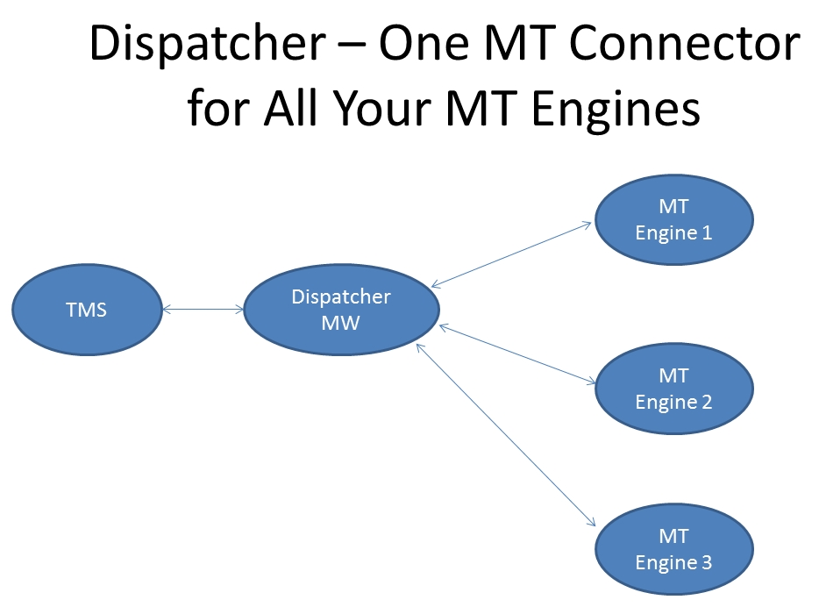

# Functional Design

Dispatcher will need to be integrated as an MT Connector into TMS such as Idiom Worldserver, SDL TMS, SmartLing, etc. on an “as requested basis” by the client with access to drop the connector into the relevant TMS. Currently, there is an MT integration in GlobalSight. For all other TMS, development work to connect to the TMS is required.   
Below is a sample mockup of an MT integration in Idiom WorldServer 9.   
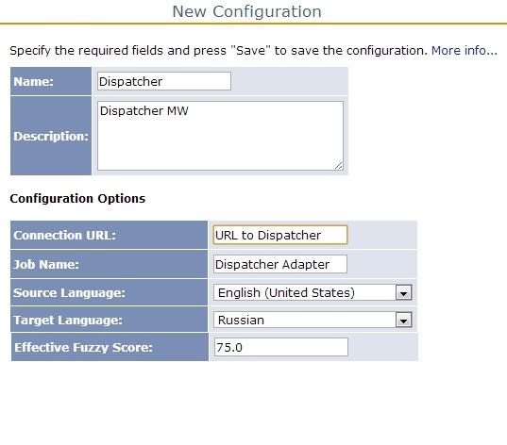

The MT engine that will be used by Dispatcher MW will depend on the language pair associated with the MT engine in the Dispatcher MW UI. In other words, in the screenshot above in Idiom WorldServer the EN>RU pair will use MS Hub.   
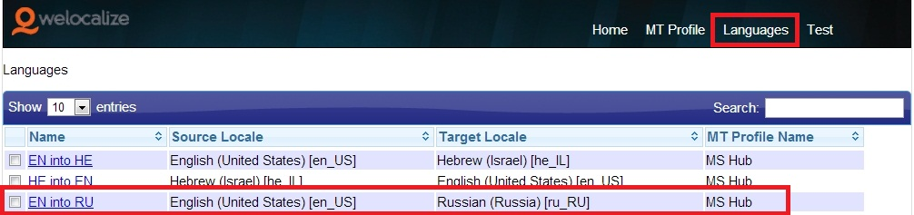

Processing Logic   
TMS sends XLIFF for all segments below certain threshold such as 75% to Dispatcher MW. Dispatcher routes to the indicated MT engine based on the MT profile and returns the translation in XLIFF format to the TMS.   
Support for plain text versus tagged text, load, performance, etc. will depend on the integration Dispatcher MW has with the specific engine. All connectors to all MT engines aggregate all the segments to be machine translated into one file and send one XLIFF to the MT engine. For non-Globalsight integrations, TMX output is not required.

Example of XLIFF input and output   
**Dispatcher MW with Moses MT connector**  
"<?xml version="1.0"?>   
<xliff version="1.2">   
<file original="None" source-language="en-US" target-language="fr-FR">   
<header>  
<tool tool-id="engine-name" tool-name"DoMT" tool-version="" />  
</header>  
<body>   
<trans-unit>   
<source><bpt erasable="yes" i="1" type="italic" x="1">&lt;i&gt;</bpt><bpt i="2" type="x-span" x="2">&lt;span style=&apos;font-family:&quot;Arial&quot;,&quot;sans-serif&quot;&apos;&gt;</bpt>Welocalize<ept i="2">&lt;/span&gt;</ept><ept i="1">&lt;/i&gt;</ept><it i="3" type="x-span" pos="begin" x="3">&lt;span style=&apos;font-family:&quot;Arial&quot;,&quot;sans-serif&quot;&apos;&gt;</it> was founded in 1997, and is a privately held, venture backed company. </source>   
<target><bpt erasable="yes" i="1" type="italic" x="1">&lt;i&gt;</bpt><bpt i="2" type="x-span" x="2">&lt;span style=&apos;font-family:&quot;Arial&quot;,&quot;sans-serif&quot;&apos;&gt;</bpt>Welocalize<ept i="2">&lt;/span&gt;</ept><ept i="1">&lt;/i&gt;</ept><it i="3" type="x-span" pos="begin" x="3">&lt;span style=&apos;font-family:&quot;Arial&quot;,&quot;sans-serif&quot;&apos;&gt;</it> a été fondée en 1997 et est une société privée soutenue par entreprise.</target>   
<alt-trans>  
<source><bpt erasable="yes" i="1" type="italic" x="1">&lt;i&gt;</bpt><bpt i="2" type="x-span" x="2">&lt;span style=&apos;font-family:&quot;Arial&quot;,&quot;sans-serif&quot;&apos;&gt;</bpt>Welocalize<ept i="2">&lt;/span&gt;</ept><ept i="1">&lt;/i&gt;</ept><it i="3" type="x-span" pos="begin" x="3">&lt;span style=&apos;font-family:&quot;Arial&quot;,&quot;sans-serif&quot;&apos;&gt;</it> was founded in 1997, and is a privately held, venture backed company. </source>   
<target><bpt erasable="yes" i="1" type="italic" x="1">&lt;i&gt;</bpt><bpt i="2" type="x-span" x="2">&lt;span style=&apos;font-family:&quot;Arial&quot;,&quot;sans-serif&quot;&apos;&gt;</bpt>Welocalize<ept i="2">&lt;/span&gt;</ept><ept i="1">&lt;/i&gt;</ept><it i="3" type="x-span" pos="begin" x="3">&lt;span style=&apos;font-family:&quot;Arial&quot;,&quot;sans-serif&quot;&apos;&gt;</it> a été fondée en 1997 et est une société privée soutenue par entreprise.</target>   
</alt-trans>  
</trans-unit>   
<trans-unit>   
<source><bpt i="1" type="x-span" x="1">&lt;span style=&apos;font-family:&quot;Arial&quot;,&quot;sans-serif&quot;&apos;&gt;</bpt>Sample Document<ept i="1">&lt;/span&gt;</ept></source>   
<target><bpt i="1" type="x-span" x="1">&lt;span style=&apos;font-family:&quot;Arial&quot;,&quot;sans-serif&quot;&apos;&gt;</bpt>Exemple de document<ept i="1">&lt;/span&gt;</ept></target>   
<alt-trans tool-id="engine-name">   
<source><bpt i="1" type="x-span" x="1">&lt;span style=&apos;font-family:&quot;Arial&quot;,&quot;sans-serif&quot;&apos;&gt;</bpt>Sample Document<ept i="1">&lt;/span&gt;</ept></source>   
<target><bpt i="1" type="x-span" x="1">&lt;span style=&apos;font-family:&quot;Arial&quot;,&quot;sans-serif&quot;&apos;&gt;</bpt>Exemple de document<ept i="1">&lt;/span&gt;</ept></target>   
</alt-trans>   
</trans-unit>   
</body>   
</file>   
</xliff>  
"

Testing setup  
The connection between Dispatcher MW and the MT engines can be tested using the Test tab of Dispatcher MW.   
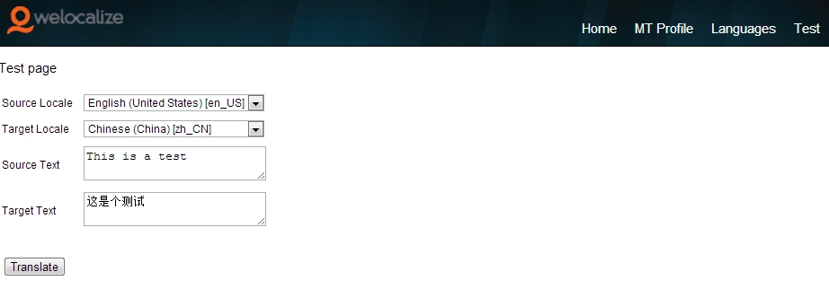

The connection between the TMS and Dispatcher MW can be tested using the Test tab of the TMS.   
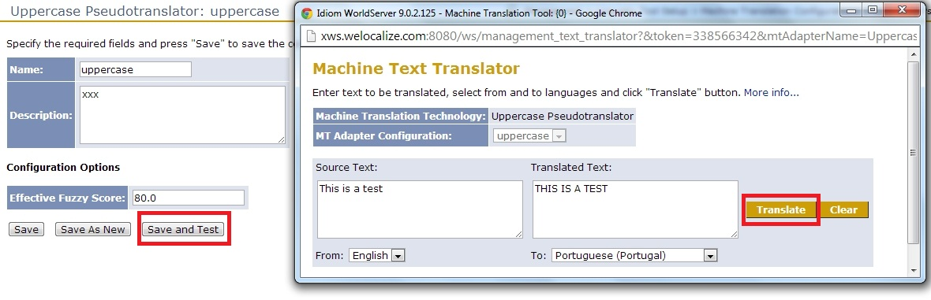

# Existing application

The existing Dispatcher UGC application already has the ability to indicate different MT engines (MT Profile) and correlate the MT engines with specific language pairs (Languages).

1. Languages.  
   Allows user to indicate source and target locales. (Based on GS Locale pairs dialog).   
   Allows user to associate the name of the MT Profile in with the locale pairs.

# 